Compound Verbal Predicate

✅ What Is a Compound Verbal Predicate?
# Source: AI Source: Provided by: [Data Path: Persons Table -> ID Column: 1, Name_En Column: Motasem Essam] -> From: [ChatGPT] on [8/4/2025]
A Compound Verbal Predicate consists of:
- A main verb, and
- One or more auxiliary verbs, modals, or infinitives
that together form a verb phrase expressing tense, mood, or aspect.
This type of predicate does not require multiple actions like a compound predicate does — it’s a single action expressed through a complex verb form.

🔸 Key Features:
# Source: AI Source: Provided by: [Data Path: Persons Table -> ID Column: 1, Name_En Column: Motasem Essam] -> From: [ChatGPT] on [8/4/2025]
- Contains auxiliary/helping verbs (e.g., has, have, is, are, was, will, can).
- May include modal verbs (should, might, could).
- May include infinitive verbs (to go, to sleep).
- Still describes one single event or state, not multiple actions.

🔸 Examples:
# Source: AI Source: Provided by: [Data Path: Persons Table -> ID Column: 1, Name_En Column: Motasem Essam] -> From: [ChatGPT] on [8/4/2025]

Sentence | Compound Verbal Predicate
She has been studying all night. | has been studying
I will have finished by tomorrow. | will have finished
We can speak French. | can speak
He wants to leave now. | wants to leave

🔸 Compare With Other Predicate Types:
# Source: AI Source: Provided by: [Data Path: Persons Table -> ID Column: 1, Name_En Column: Motasem Essam] -> From: [ChatGPT] on [8/4/2025]
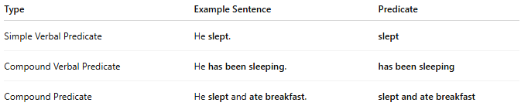
Type | Example Sentence | Predicate
Simple Verbal Predicate | He slept. | slept
Compound Verbal Predicate | He has been sleeping. | has been sleeping
Compound Predicate | He slept and ate breakfast. | slept and ate breakfast

✅ Compound Verbal Predicate = complex verb form
❌ Not to be confused with Compound Predicate = two separate actions

